

[Your Company Name]
[Your Tagline]

Business
Plan
[YEAR]

Prepared By
Alex Doe

10220 Bolsa Ave, Westminster, CA, 9268

Table of Contents

1. The Quick Pitch : Executive Summary
7
Business Name and Location
Vision Statement
Market Opportunity
Key Products/Services
Marketing Strategies
Financial Highlights
2. Business Overview
9
Business Concept
Legal Structure
Owners
Mission Statement
Background History
Goals and Objectives
3. Market Analysis
11
Industry Overview
Market Size and Growth Potential
Target Market
Customer Analysis
Potential customers
Market Trends
Regulatory Compliance

4. Competitive Analysis
14
Key Competitors
SWOT Analysis
Competitive Advantages
5. Product and Services
16
Product/Service Description
Benefits to Customers
Pricing Strategy
Future Expansion
6. Sales and marketing strategies
17
Unique Selling Proposition (USP)
Branding Strategy
Marketing Plan
Sales Tactics
Customer retention
7. Operations Plan
19
Staffing and training
Daily Operations
Suppliers and Vendors
Technology/Tools used

8. Management Team
20
Owner/Founder Profile
Key managers
Organizational Structure
Compensation Plan
Advisory Board Members
9. Financial Plan
22
Important Assumptions
Sales and Revenue Forecasts
Profit and Loss Statement
Cash Flow Statement
Balance Sheet
Break-Even Analysis
Funding Needs
Use of Funds
10. Risk Management
30
Risk Identification
Mitigation Strategies
Crisis Management Plans
Legal Compliance Risks

11. Exit strategies
31

Acquisition Targets
Public Offering (IPO)
Succession Planning
Liquidation Plans

Switch to Bizplanr for simpler and faster business planning
Using traditional templates can be incredibly tedious & frustrating. You need a tool that not only makes business planning easier and faster, but also fun.
Switch to Bizplanr for streamlined business plan creation. With Bizplanr AI assistance, you can create a comprehensive plan with accurate financials in a fraction of time—an investment-ready plan that puts professionals to shame.
 | AI business assistant  Get your own personal business coach that helps you write sections of your plan, forecast financials, conduct market research, or answer any of your planning questions. Ask anything.  See how it works
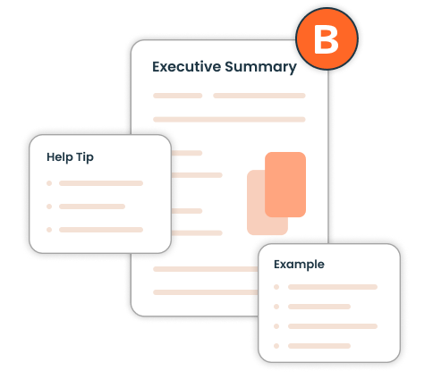 | Guided business plan builder  A guided plan builder with step-by-step instructions for even the most minute steps. We make planning easier with prompt help and examples on every step of your plan writing process.  See how it works
 | Automated & accurate financial projections  Creating accurate financial projections doesn’t require an accounting degree, at least not with Bizplanr. Enter the sales, expenses, and other numbers, and see your projections taking shape.  See how it works
 | 400+ Sample business plans  Get access to hundreds of sample business plans covering almost all industries to kick start your business plan writing. This helps you to get an idea how a perfect business plan should look like.  View Sample Business Plans

1. Executive Summary

Business Name and Location
💡 Help Tip:
State the name of your business and its primary location, when it was founded, and the type of business you run. Explain why this location is strategic for your target market, supply chain, or operations.

Vision Statement
💡 Help Tip:
Summarize your long-term aspirations and how your business aims to impact the market. Highlight plans for growth, expansion, or industry innovation to inspire confidence in your vision.

Market Opportunity
💡 Help Tip:
Provide insights into your target market size, trends, and growth potential. Mention specific market gaps your business addresses and how your offerings meet customer needs better than competitors.

Key Products/Services
💡 Help Tip:
List the main products or services you offer and focus on how they address customer needs or pain points. Highlight any unique features, technologies, or benefits that make them stand out.

Marketing Strategies
💡 Help Tip:
Briefly outline your marketing approach, including online and offline strategies like SEO, social media, and events. Highlight key campaigns, partnerships, or tools that will drive customer acquisition and retention.

Financial Highlights
💡 Help Tip:
Provide a snapshot of projected revenue, profit margins, and funding needs. Highlight key financial milestones and any major expenses, like equipment or marketing, that will drive growth.
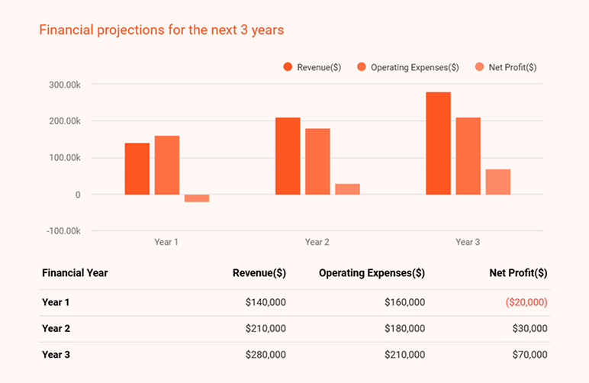

2. Business Overview

Business Concept
💡Help Tip:
Describe the problem your business solves and how it delivers value to customers. Highlight your unique approach or innovation and explain why your solution is better than existing alternatives.

Legal Structure
💡 Help Tip:
Clearly state the legal structure of your business—LLC, corporation, partnership, or sole proprietorship. Explain why this structure is ideal for your operations, taxes, and liability protection.

Owners
💡 Help Tip:
List who owns the business and what roles they play. If they bring special skills, experience, or financial backing to the table, make sure to mention it.


Mission Statement
💡 Help Tip:
Write a short, impactful statement about your purpose and values. Focus on how your business helps customers and contributes to the community or industry.

Background History
💡 Help Tip:
Share how and why you started the business. Include any challenges you overcame, important milestones, or personal experiences that shaped your journey.

Goals and Objectives
💡 Help Tip:
List specific, measurable goals for the short and long term. Are you launching a new product soon or aiming to hit certain revenue targets? Be clear and realistic about what you want to achieve.



Get started
Spending a little too much time writing?
Instantly improve your writing & speed
Bizplanr’s AI assistant simplifies plan writing, so you spend less time writing, more brainstorming & strategizing.

3. Market Analysis

Industry Overview
💡 Help Tip:
Provide an overview of your industry, including its size, growth potential, and future outlook. Highlight emerging opportunities and explain how your business is positioned to benefit from these trends.

Market Size and Growth Potential
💡 Help Tip:
Estimate your market size and projected growth using data from industry reports or market studies. Highlight trends, demand drivers, and growth opportunities that position your business for success. Include statistics or forecasts to support your claims..



Target Market
💡 Help Tip:
Define the specific group or segment within the market that your business will focus on. Highlight its characteristics, trends, and demand patterns that make it a strategic choice for your business.

Customer Analysis

💡 Help Tip:
Describe your target customers, focusing on demographics, interests, and behaviors. Highlight their needs, purchasing motivations, and how your product or service solves their problems. Show how this aligns with your business goals.

Potential customers
💡 Help Tip:
Identify groups most likely to need your product or service based on age, income, lifestyle, and buying habits. Explain their challenges, preferences, and spending behaviors. Highlight how your business meets their needs better than competitors.

Buyer persona
💡 Help Tip:
Create a detailed profile of your ideal customer, including age, job title, income, and interests. Focus on their goals, pain points, and decision-making processes. Use this profile to guide marketing, sales, and customer service strategies.

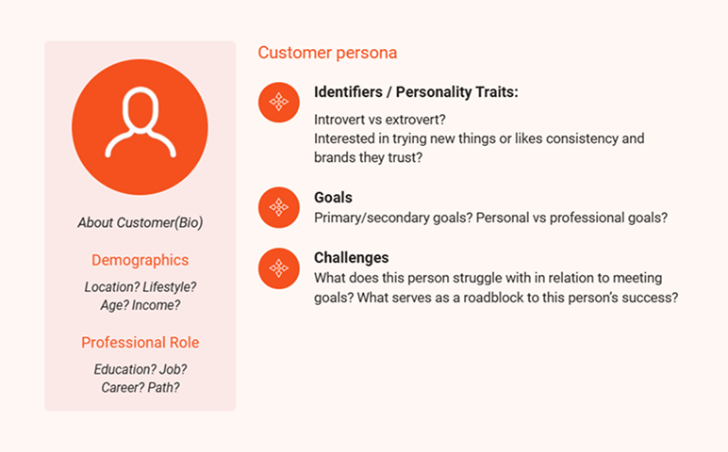

Market Trends
💡 Help Tip:
Identify key trends in your industry—shifts in customer preferences, new technologies, or rising demands. Show how your business is ready to adapt or take advantage of these trends.

Regulatory Compliance
💡 Help Tip:
Provide a snapshot of projected revenue, profit margins, and funding needs. Highlight key financial milestones and any major expenses, like equipment

4. Competitive Analysis

Key Competitors
💡 Help Tip:
List the main businesses you’ll be competing with in your market. Highlight their strengths, weaknesses, and unique offerings. Explain how your business stands out by filling gaps, offering better value, or addressing unmet customer needs.

SWOT Analysis
💡 Help Tip:
List your business’s strengths (what you do well), weaknesses (areas to improve), opportunities (ways to grow), and threats (challenges to watch out for). Focus on being honest and practical about how you’ll build on strengths, fix weaknesses, use opportunities, and protect against threats.

Strengths  (Write about what your business does well, like good products, loyal customers, or skilled employees. Focus on things that make your business strong.) | Weaknesses  (Be honest about what your business struggles with, like high costs or lack of marketing. Mention how you plan to fix these problems.)
Opportunities  (Talk about ways your business can grow, like new trends, online sales, or new products. Focus on ideas to take advantage of these changes.) | Threats  List problems your business might face, like tough competition or new rules. Share ways to protect your business from these risks.)

Competitive Advantages

💡 Help Tip:
Explain the factors that give your business an edge in the market. Focus on areas like operational efficiency, strategic partnerships, exclusive resources, industry expertise, or faster delivery times. Highlight how these strengths position your business for long-term success.

Get started
Spending a little too much time writing?
Instantly improve your writing & speed
Bizplanr’s AI assistant simplifies plan writing, so you spend less time writing, more brainstorming & strategizing.

5. Product and Services

Product/Service Description
💡 Help Tip:
Give details about your products or services—what they are, how they work, and what materials or processes are involved. Highlight any features that make them special.

Benefits to Customers
💡 Help Tip:
Explain how your products or services make life easier, save time, or solve specific problems. Focus on practical benefits like quality, affordability, or convenience.

Pricing Strategy
💡 Help Tip:
Break down your pricing model. Is it competitive, premium, or value-based? Explain how your pricing reflects your product’s value and whether you offer discounts or bundles.

Future Expansion
💡 Help Tip:
Share ideas for expanding your product or service line, such as launching new offerings, adding features, or upgrading existing products. Highlight how these plans align with customer needs and market trends.

6. Sales and Marketing Strategies

Unique Selling Proposition (USP)
💡 Help Tip:
Highlight what makes your business stand out—whether it’s price, quality, convenience, or customer service. Focus on how your offering solves a specific problem better than others.

Branding Strategy
💡 Help Tip:
Describe how your logo, slogan, and messaging create a strong brand identity. Focus on how your brand reflects your values and resonates with your target audience.

Marketing Plan
💡Help Tip:
Outline your marketing methods, including online strategies like SEO, social media, and email campaigns, as well as offline approaches like flyers, events, and PR campaigns.

Sales Tactics

💡 Help Tip:
Explain your sales approach, such as direct sales, partnerships, retail outlets, or e-commerce platforms. Highlight strategies for closing deals and reaching revenue targets.

Customer Retention
💡 Help Tip:
List strategies to retain customers, like loyalty programs, referral incentives, personalized follow-ups, and after-sales services. Focus on building long-term relationships.

Get started
Spending a little too much time writing?
Instantly improve your writing & speed
Bizplanr’s AI assistant simplifies plan writing, so you spend less time writing, more brainstorming & strategizing.

7. Operations Plan

Staffing and training
💡 Help Tip:
List the key roles required to run your business and highlight plans for hiring and training. Focus on how your team will grow to meet future demands and maintain high performance.

Daily Operations
💡 Help Tip:
Describe the core activities required to keep your business running, including workflows, schedules, and processes. Mention any production steps or service delivery methods involved.

Suppliers and Vendors
💡 Help Tip:
List your key suppliers and vendors for raw materials, equipment, or inventory. Explain how you’ll maintain relationships and ensure consistent quality and delivery.

Technology/Tools used
💡 Help Tip:
Highlight the tools, software, and systems you’ll use to manage operations, track performance, and streamline processes. Mention specific technologies for inventory, accounting, or customer service.

8. Management Team

Owner/Founder Profile
💡 Help Tip:
Provide details about the owner’s experience, expertise, and vision for the business. Jot down any relevant achievements or skills that demonstrate leadership and industry knowledge.

Key managers
💡 Help Tip:
List important team members, their roles, and responsibilities. Include brief resume-styled summaries that highlight their qualifications, expertise, and contributions to the business.

Organizational Structure
💡 Help Tip:
Show the structure of your team with a visual chart, illustrating reporting relationships and how decisions are made within the business.
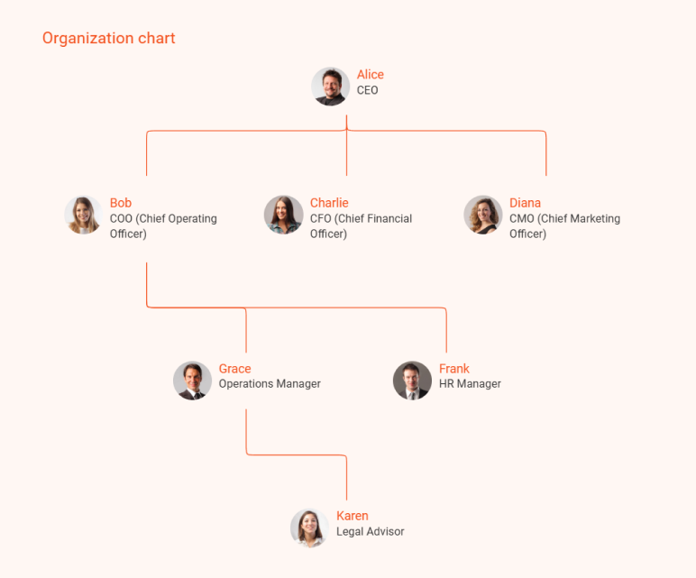

Compensation Plan
💡 Help Tip:
Outline salaries, bonuses, and benefits for owners, managers, and employees. Highlight how the compensation structure supports motivation and performance.
Advisory Board Members
💡 Help Tip:
Mention any advisors, consultants, or mentors providing strategic guidance. Highlight their expertise and how they add value to your business.

9. Financial Plan

Important Assumptions

💡 Help Tip:
List the key assumptions that shape your financial forecasts, such as market conditions, pricing, sales volume, and economic trends. Make sure these assumptions are realistic and supported by data.

Sales and Revenue Forecasts

💡 Help Tip:
Provide estimates of your expected sales and revenue over a specific period. Base your forecasts on market research, pricing strategies, and growth projections to give a clear picture of your business’s earning potential.

Year | Projected Sales (Units) | Revenue ($) | Growth Rate (%)
FY 1
FY 2
FY 3

Profit and Loss Statement
💡 Help Tip:
Provide a summary of your expected revenue, costs, and profits over a specific period. Highlight projected profitability and any strategies to increase margins.

Category | FY 1 | FY 2 | FY3
Revenue
Sales Revenue
Other Income
Total Revenue
Cost of Goods Sold (COGS)
Materials and Supplies
Labor Costs
Other Direct Costs
Total COGS
Gross Profit
Operating Expenses
Salaries and Wages
Rent
Utilities
Marketing and Advertising
Insurance
Depreciation
Office Supplies
Miscellaneous Expenses
Total Operating Expenses
Operating Profit (EBIT)
Interest Expense
Net Profit Before Tax
Income Tax (20%)
Net Profit After Tax

Get started
Struggling with numbers & financial calculations?

Accurate financial projections made faster
Bizplanr's AI-powered forecasting tool eliminates formulas and manual calculations from the process.

Cash Flow Statement
💡 Help Tip:
Track how cash moves in and out of your business to ensure liquidity. Include expected payment cycles, major expenses, and cash reserves for stability.

Category | 1 | 2 | 3
Cash Flow from Operating
Activities
Net Income
Adjustments for Non-Cash
Items:
– Depreciation
–Changes in Working Capital
-- Increase in Accounts Receivable
-- Decrease in Inventory
-- Increase Accounts Payable
Net Cash Flow from Operations
Cash Flow from Financing Activities
Loan Proceeds
Loan Repayment
Issuance of Equity Capital
Net Cash Flow from Financing
Net Increase in Cash
Opening Cash Balance
Closing Cash Balance

Balance Sheet
💡 Help Tip:
Show a snapshot of your business’s financial position, including assets, liabilities, and equity. Use it to demonstrate your financial health and borrowing capacity.

Category | 1
Assets
Current Assets:
Cash
Accounts Receivable
Inventory
Prepaid Expenses
Total Current Assets
Non-Current Assets:
Property, Plant, and Equipment
Less: Accumulated Depreciation
Intangible Assets (if any)
Total Non-Current Assets
Total Assets
Liabilities and Equity
Current Liabilities:
Accounts Payable
Short-Term Loans
Taxes Payable
Total Current Liabilities
Long-Term Liabilities:
Long-Term Loans
Total Long-Term Liabilities
Equity:
Owner’s Capital
Retained Earnings
Total Equity
Total Liabilities & Equity

Get started
Struggling with numbers & financial calculations?

Accurate financial projections made faster
Bizplanr's AI-powered forecasting tool eliminates formulas and manual calculations from the process.

Break-Even Analysis
💡 Help Tip:
Calculate the sales volume required to cover costs and reach profitability. Use this to demonstrate how quickly your business can generate profits.

Category
Fixed Costs
Rent
Salaries
Utilities
Insurance
Marketing and Advertising
Depreciation
Miscellaneous Expenses
Total FixedCosts
Variable Costs (Per Unit):
Raw Materials
Labor Costs
Packaging
Shipping
Total Variable Cost Unit
Selling Price Per Unit
Contribution
Margin Per Unit
Break-even (Units):
Total Fixed Costs ÷ Contribution Margin
Break-even Point (Revenue):
Break-even Units × Selling Price

Funding Needs
💡 Help Tip:
Specify the total capital required to launch or grow your business. Explain whether it will come from personal funds, loans, or investors, and highlight your repayment plan.

Use of Funds
💡 Help Tip:
Break down how funds will be used, such as setup, marketing, or operations. Highlight investments in technology, staff, and growth strategies. Focus on how each expense drives business success.

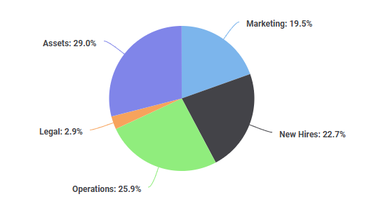

Get started
Struggling with numbers & financial calculations?

Accurate financial projections made faster
Bizplanr's AI-powered forecasting tool eliminates formulas and manual calculations from the process.

10. Risk Management

Risk Identification
💡 Help Tip:
List internal and external risks like equipment failure, supplier issues, and economic downturns. Focus on realistic and specific challenges.

Mitigation Strategies
💡 Help Tip:
Explain measures like insurance coverage, backup suppliers, and cybersecurity to minimize risks and ensure business continuity.

Crisis Management Plans
💡 Help Tip:
Provide a simple emergency response plan with key team roles, communication protocols, and recovery steps for disasters or PR crises.

Legal Compliance Risks
💡 Help Tip:
Highlight strategies for staying compliant, including regular audits, legal reviews, and employee training to avoid fines or penalties.

11. Exit strategies

Acquisition Targets

💡 Help Tip:
Highlight how your business could attract larger companies for acquisition by showcasing unique value, intellectual property, or competitive advantages.

Public Offering (IPO)
💡 Help Tip:
Explain steps to prepare for going public, including financial growth plans, legal compliance, and investor readiness.

Succession Planning

💡 Help Tip:
Outline plans to transfer ownership or management to family members, employees, or trusted individuals through training and mentoring programs.

Liquidation Plans
💡 Help Tip:
Describe strategies to close the business, sell assets, repay debts, and minimize losses while supporting employees during the process.

Switch to Bizplanr for simpler and faster business planning
Using traditional templates can be incredibly tedious & frustrating. You need a tool that not only makes business planning easier and faster, but also fun.
Switch to Bizplanr for streamlined business plan creation. With Bizplanr AI assistance, you can create a comprehensive plan with accurate financials in a fraction of time—an investment-ready plan that puts professionals to shame.
AI business assistant
Get your own personal business coach that helps you write sections of your plan, forecast financials, conduct market research, or answer any of your planning questions. Ask anything.
See how it works
Guided business plan builder
A guided plan builder with step-by-step instructions for even the most minute steps. We make planning easier with prompt help and examples on every step of your plan writing process.
See how it works
Automated & accurate financial projections
Creating accurate financial projections doesn’t require an accounting degree, at least not with Bizplanr. Enter the sales, expenses, and other numbers, and see your projections taking shape.
See how it works
400+ Sample business plans
Get access to hundreds of sample business plans covering almost all industries to kick start your business plan writing. This helps you to get an idea how a perfect business plan should look like.
View Sample Business Plans

